Student Name:M.Bhuvaneshwar
Student ID:11801892
Email Address:mattapallibhuvaneshwar9640@gmail.com
Section:K18AW ,Roll no:24
Course Code: CSE 316 Course Title: Operating System
GitHub Link:
Question numbers allocated to me (11,14.)

Question number:11

Discription:
Given an array of disk track numbers and initial head position, our task is to find the total number of seek operations done to access all the requested tracks if SCAN disk scheduling algorithm is used.
In SCAN algorithm the disk arm moves into a particular direction and services the requests coming in its path and after reaching the end of disk, it reverses its direction and again services the request arriving in its path. So, this algorithm works as an elevator and hence also known as elevator algorithm. As a result, the requests at the midrange are serviced more and those arriving behind the disk arm will have to wait.

Code for the given question 11:

#include<stdio.h>
#include<conio.h>
int main()

{ int i,j,temp,Sum1=0,Sum2=0,CPOS,ID,TD=0,ID1;
int array[15]={143,86,1470,913,1774,948,1509,1022,1750,130,4999,0};
printf("Number of Disc in the cylinder:(0-4999)= 5000 \n");
printf("Current request being processed in cylinder : 143 \n");
printf("Previous request that has been processed : 125 \n");
//it is just showing that is is moving toward positive direction
printf("Elements in FIFO list : \n");
printf("143,86 1470 913 1774 948 1509 1022 1750 130");
//also store boundary value
int min=array[0];
for(i=0;i<12;++i)
{
for(j=i+1;j<12;++j)
{
if(array[i]>array[j])
{
temp=array[i];
array[i]=array[j];
array[j]=temp;
}
}
}
printf("\nElements in Sorted form: ");
for(i=0;i<12;++i)
{
printf("%d \t",array[i]);
}
printf("\nCurrent position of the pointer in sorted array : ");
for(i=0;i<12;++i)
{
if(array[i]==143)
{
printf("%d \n",i+1);
CPOS=i;
}
}
printf("Individual distance from moving current position to disc Size(4999) \n");
for(i=CPOS;i<12-1;++i)
{ ID=array[i+1]-array[i];
printf("%d \n",ID);
Sum1=Sum1+ID;
}
printf(" Distance from current position to 4999 : %d \n",Sum1);
printf("Individual distance from moving 0 to Current size\n");
for(i=0;i<CPOS-1;i++)
{
ID1=array[i+1]-array[i];
printf("%d \n",ID1);
Sum2=Sum2+ID1;
}
printf(" Distance from 0 to current position : %d \n",Sum2);
TD=Sum1+Sum2;
printf("Distance when we don't include the distance from 4999 to 0: \n");
printf("%d \n",TD);
printf("Distance when we include the distance from 4999 to 0: \n");
printf("%d ",TD+4999);
} output for the given program:
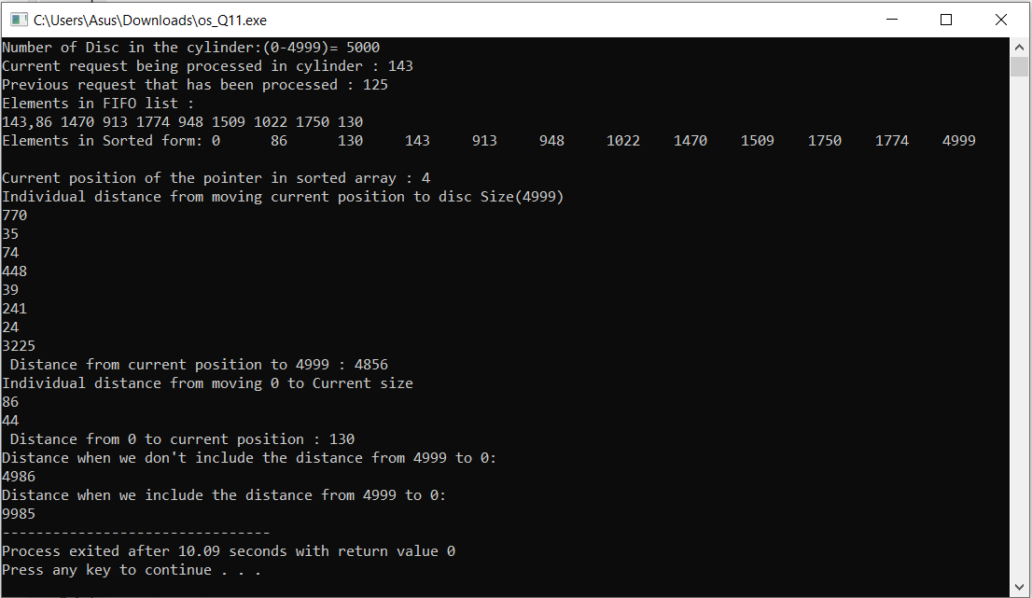

SCAN Disk Scheduling Algorithm-

- As the name suggests, this algorithm scans all the cylinders of the disk back and forth.
- Head starts from one end of the disk and move towards the other end servicing all the requests in between.
- After reaching the other end, head reverses its direction and move towards the starting end servicing all the requests in between.
- The same process repeats.

NOTE-

- SCAN Algorithm is also called as Elevator Algorithm.
- This is because its working resembles the working of an elevator.

Advantages-

- It is simple, easy to understand and implement.
- It does not lead to starvation.
- It provides low variance in response time and waiting time.

Disadvantages-

- It causes long waiting time for the cylinders just visited by the head.
- It causes the head to move till the end of the disk even if there are no requests to be serviced.

Question number:14

DISCRIPTION:
If a teacher is being served at the food mess and during the period when he is being served, another teacher comes, then that teacher would get the service (food) next. This process might continue leading to increase in waiting time of students to get food. Ensure in your program that the waiting time of students is minimized.
In this question the teachers are serving food one by one and the time of getting food to student min and we have to calculate the average time of getting served by teacher by the programming.

Code for the given question:

#include<stdio.h>
#include<conio.h>
int main()
{
int i, n, total = 0, x, counter = 0, time_quantum;
int wait_time = 0, turnaround_time = 0, arrival_time[10], burst_time[10], temp[10];
float average_wait_time, average_turnaround_time;
printf("\nEnter Total Number of Processes:\t");
scanf("%d", &n);
x = n;
for(i = 0; i < n; i++)
{
printf("\nEnter Details of Process[%d]\n", i + 1);
printf("Arrival Time:\t");
scanf("%d", &arrival_time[i]);
printf("Burst Time:\t");
scanf("%d", &burst_time[i]);
temp[i] = burst_time[i];
}
printf("\nEnter Time Quantum:\t");
scanf("%d", &time_quantum);
printf("\nProcess ID\t\tBurst Time\t Turnaround Time\t Waiting Time\n");
for(total = 0, i = 0; x != 0;)
{
if(temp[i] <= time_quantum && temp[i] > 0)
{
total = total + temp[i];
temp[i] = 0;
counter = 1;
}
else if(temp[i] > 0)
{
temp[i] = temp[i] - time_quantum;
total = total + time_quantum;
}
if(temp[i] == 0 && counter == 1)
{
x--;
printf("\nProcess[%d]\t\t%d\t\t %d\t\t\t %d", i + 1, burst_time[i], total - arrival_time[i], total - arrival_time[i] - burst_time[i]);
wait_time = wait_time + total - arrival_time[i] - burst_time[i];
turnaround_time = turnaround_time + total - arrival_time[i];
counter = 0;
}
if(i == n - 1)
{
i = 0;
}
else if(arrival_time[i + 1] <= total)
{
i++;
}
else
{
i = 0;
}
}
average_wait_time = wait_time * 1.0 / n;
average_turnaround_time = turnaround_time * 1.0 / n;
printf("\n\nAverage Waiting Time:\t%f", average_wait_time);
printf("\nAvg Turnaround Time:\t%f\n", average_turnaround_time);
return 0;
}
Output for the given program:
